PROJECT REPORT OF CO-OP
Project at Industry (Module-2)

ON

A Deep Learning-Based Framework for Autonomous Driving
Software in Electric Vehicles

submitted in partial fulfilment of the requirements for the award of degree of

BACHELOR OF ENGINEERING
In
COMPUTER SCIENCE AND ENGINEERING

Submitted by: Supervised By:
Llywellyn Sana Thaoroijam Dr. Simarjit Kaur
2210991854 Associate Professor



DEPARTMENT OF COMPUTER SCIENCE AND ENGINEERING
CHITKARA UNIVERSITY INSTITUTE OF ENGINEERING AND TECHNOLOGY
CHITKARA UNIVERSITY, PUNJAB, INDIA
2024-2025

DECLARATION

I hereby certify that the work which is being presented in the project report entitled "A Deep Learning-Based Framework for Autonomous Driving Software in Electric Vehicles" in partial fulfilment of requirement for the award of the degree of Bachelor of Engineering (Computer Science and Engineering) submitted in the department of Computer Science and Engineering at Chitkara University Institute of Engineering and Technology, Chitkara University, Punjab, India, is an authentic record of my own work carried out under the supervision of Dr. Simarjit Kaur, Associate Professor. The matter presented in this project report has not been submitted in any other university/institute for the award of any degree.

Place: Rajpura
Date: ………………

Llywellyn Sana Thaoroijam
Roll No. 2210991854

This is to certify that the above statement made by the candidate is correct to the best of my knowledge and belief.

Dr. Simarjit Kaur
Associate Professor
Department of Computer Science and Engineering
Chitkara University Institute of Engineering and Technology,
Chitkara University, Punjab, India

ACKNOWLEDGEMENT

The author would like to express sincere gratitude to Dr. Simarjit Kaur, Associate Professor, Department of Computer Science and Engineering, Chitkara University Institute of Engineering and Technology, Chitkara University, Rajpura, for her guidance, support, and valuable feedback throughout the development of this project.

The author also acknowledges the use of publicly available datasets such as BDD100K and open-source tools and frameworks including Python, TensorFlow/PyTorch, OpenCV, and YOLO, which significantly contributed to the implementation of this work.

Sincere appreciation is also extended to the Office of Student Affairs at Chitkara University for providing the internship opportunity and the necessary resources and environment that made this research possible.

Finally, appreciation is extended to all individuals and resources that directly or indirectly supported the successful completion of this research work.

Llywellyn Sana Thaoroijam
221099185

ABSTRACT

Getting autonomous vehicles to navigate real-world roads, especially the chaotic and unpredictable streets typical of Indian traffic, remains one of the trickiest challenges in modern transportation. While electric vehicles are becoming increasingly common, they still need intelligent systems that can operate effectively in environments where lane markings might be faded, and where a cow, a cyclist, and a truck might share the same lane without warning.

This report presents a deep learning framework specifically developed for electric vehicles (EVs) that handles these complex realities. Using YOLOv8, the system detects vehicles, pedestrians, and traffic signals in real-time, while a lane detection pipeline combining Canny edge detection with polynomial curve fitting tracks road boundaries even when pavement markings are absent or unclear. From these detected lanes, a dynamic centre path is generated to guide navigation decisions.

The entire system is wrapped in a Flask-based web interface that handles both local video files and live streams. In practice, the system runs at a solid 35-55 FPS on standard GPU hardware, maintaining stable visual outputs even under challenging road conditions. The results suggest this approach can scale effectively for intelligent EV systems operating in real-world scenarios.

Keywords: Autonomous Driving, Deep Learning, YOLOv8, Lane Detection, Electric Vehicles

CONTENTS

Sr. No. | Title | Page No.
 | Acknowledgement | iii
 | List of Figures | iv
 | Abstract | v
1 | Introduction | 1
2 | Problem Statement | 3
3 | Objectives | 5
4 | Methodology | 6
5 | Tools and Technologies | 9
6 | Results and Discussion | 10
7 | Conclusion and Future Scope | 13
 | References | 15
Figure No. | Title | Page No.
Fig. 1 | Training batch sample with bounding box annotations (BDD100K subset) | 11
Fig. 2 | Dataset label distribution and bounding box statistics (BDD100K subset) | 11
Fig. 3 | Training and validation loss curves and performance metrics over epochs | 12
Fig. 4 | Normalized confusion matrix showing per-class detection performance | 12
Fig. 5 | Validation batch predictions with labelled detections | 13

1. INTRODUCTION

Autonomous driving has rapidly evolved as one of the most impactful applications of artificial intelligence in modern transportation systems. With the increasing adoption of electric vehicles (EVs), there is a growing need for intelligent software systems that can ensure safe, efficient, and autonomous navigation. These systems aim to minimize human intervention by enabling vehicles to perceive their environment, interpret complex road scenarios, and make real-time driving decisions. However, achieving full autonomy remains a challenging task, especially in diverse and unstructured environments such as Indian roads, where traffic conditions are highly dynamic and often unpredictable.

The core of autonomous driving lies in three primary components: perception, decision-making, and control. Perception involves understanding the surroundings using sensors and computer vision techniques, including object detection, lane detection, and traffic signal recognition. Decision-making involves analysing this information to determine the optimal driving path, while control ensures the execution of these decisions through steering, acceleration, and braking. Among these, perception is the most critical and computationally intensive task, as it directly affects the reliability and safety of the system.

Recent advancements in deep learning have significantly improved the capabilities of perception systems. Convolutional Neural Networks (CNNs) have shown exceptional performance in image classification, object detection, and scene understanding tasks. Algorithms such as YOLO (You Only Look Once) have enabled real-time object detection with high accuracy and efficiency, making them suitable for autonomous driving applications. Similarly, lane detection techniques based on edge detection, region-of-interest segmentation, and curve fitting have been widely used to identify road boundaries and estimate vehicle positioning.

Despite these advancements, several challenges persist. Variations in lighting conditions, weather changes, occlusions, and poor road infrastructure can negatively impact detection accuracy. In addition, Indian road scenarios often include irregular lane markings, mixed traffic (vehicles, pedestrians, animals), and unpredictable driving behaviours, which make it difficult for conventional models to generalize effectively. Therefore, there is a need for a robust and adaptive framework that can integrate multiple perception modules while maintaining real-time performance and stability.

To address these challenges, researchers have explored both end-to-end and modular approaches for autonomous driving. End-to-end approaches attempt to map raw sensor inputs directly to control outputs using deep neural networks, while modular approaches divide the system into distinct components such as perception, planning, and control. Modular systems offer better interpretability, flexibility, and ease of debugging, making them more suitable for practical implementations and academic research.

In this project, a deep learning-based framework for autonomous driving software specifically designed for electric vehicles is proposed. The system integrates YOLOv8 for real-time object detection, a lane detection module using Canny edge detection and polynomial curve fitting, and a dynamic path planning mechanism that calculates a central driving path between detected lanes. The system is deployed using a Flask-based web interface, enabling real-time visualization and interaction with both local and streamed video inputs.

The key contributions of this work include: (i) the development of a unified framework combining object detection, lane detection, and path planning; (ii) real-time performance optimization achieving stable frame rates of 35-55 FPS on GPU hardware; and (iii) a scalable and modular architecture suitable for real-world deployment in electric vehicles.

2. PROBLEM STATEMENT
Autonomous driving systems have made significant progress in recent years; however, their reliable deployment in real-world environments remains a major challenge. Most existing systems are developed and tested under structured road conditions with clear lane markings, controlled traffic behaviour, and consistent environmental settings. In contrast, real-world driving scenarios, particularly in countries like India, present highly unstructured and unpredictable conditions, including irregular or missing lane markings, mixed traffic consisting of vehicles, pedestrians, and animals, and frequent violations of traffic rules. These factors make it difficult for conventional autonomous driving systems to perform accurately and consistently.

One of the key challenges lies in achieving robust perception. Object detection models often face difficulty in maintaining high accuracy under varying lighting conditions, occlusions, weather disturbances, and dense traffic scenarios. Similarly, lane detection becomes unreliable when lane markings are faded, curved, or completely absent. Traditional computer vision approaches are not sufficiently adaptive to handle such variations, while deep learning models may suffer from generalization issues when exposed to unseen environments.

Another critical issue is the lack of effective integration between different modules of autonomous driving systems. Many existing approaches treat object detection, lane detection, and path planning as separate tasks without ensuring seamless coordination between them. This results in increased computational complexity, latency issues, and reduced real-time performance. Furthermore, maintaining a balance between accuracy and speed is essential, as autonomous systems must operate in real time to ensure safety.

In addition, there is limited focus on developing scalable and user-friendly systems that allow real-time monitoring, testing, and interaction. Most implementations are restricted to simulation environments or lack proper visualization interfaces, making it difficult to evaluate system behaviour in practical scenarios. The absence of such interfaces also limits accessibility for further research and development.

Therefore, there is a need for a robust, efficient, and integrated framework that combines object detection, lane detection, and path planning into a unified system capable of operating in real time. The system should be adaptable to complex and unstructured environments, provide stable and accurate outputs, and support real-time visualization for effective evaluation.

3. OBJECTIVES

3.1 Primary Objective
The primary objective of this study is to develop a deep learning-based framework for autonomous driving in electric vehicles that enables real-time perception, decision-making, and navigation in complex and dynamic road environments. The system aims to improve safety and efficiency by reducing human intervention through intelligent automation.

3.2 Object Detection Module
This project focuses on implementing a real-time object detection system using YOLOv8 to accurately identify vehicles, pedestrians, and traffic signals. The objective is to ensure reliable environmental perception under varying road and lighting conditions.

3.3 Lane Detection and Path Planning
A key objective is to develop a robust lane detection system using Canny edge detection, region-of-interest masking, and polynomial curve fitting. Based on the detected lanes, a dynamic path planning mechanism is designed to generate a safe and optimal driving trajectory.

3.4 System Integration
The proposed work aims to integrate object detection, lane detection, and path planning into a unified and modular architecture. This integration ensures efficient processing, scalability, and ease of system implementation.

3.5 Deployment and Evaluation
The framework is deployed using a Flask-based interface to enable real-time visualization and interaction with video inputs. The system is evaluated based on performance metrics such as frame rate (FPS), detection accuracy, and visual stability to ensure its effectiveness in real-world scenarios.

4. METHODOLOGY

4.1 Dataset and Preprocessing
The proposed system utilizes a subset of the BDD100K dataset for training and validation. This dataset contains diverse driving scenarios, making it suitable for autonomous driving applications. The images are pre-processed through resizing and normalization to ensure consistency in input dimensions and improved model performance. Data augmentation techniques such as flipping, rotation, and zooming are applied to increase dataset diversity and enhance model generalization.

4.2 Model Architecture
A custom Convolutional Neural Network (CNN) is designed for feature extraction and classification tasks. The architecture consists of multiple convolutional layers followed by pooling layers to capture spatial features, and fully connected dense layers for classification. This structure enables the model to learn hierarchical features from input images effectively. YOLOv8, a state-of-the-art single-stage object detection model, is integrated at the detection stage due to its speed and accuracy.

4.3 Lane Detection Pipeline
The lane detection module employs a sequence of classical computer vision techniques combined with deep learning outputs. First, the input frame is converted to grayscale and Gaussian blurring is applied to reduce noise. Canny edge detection is then used to identify strong gradient regions corresponding to road markings. A region of interest (ROI) mask focuses the computation on the lower portion of the frame where lanes are most likely to appear. Finally, polynomial curve fitting (second-degree) is applied to the detected edge points to produce smooth lane curves, from which a dynamic centre path is computed for navigation.

4.4 Training Strategy
The model is trained using GPU acceleration to optimize computational efficiency. Batch processing is employed to handle large datasets, and performance is monitored using training and validation accuracy metrics. The training process ensures that the model achieves a balance between accuracy and generalization across varied road environments.

4.5 Explainability Techniques
To improve interpretability, various explainability techniques are incorporated into the system. Feature map visualization is used to understand intermediate representations learned by the model. Saliency maps highlight important regions in the input images, while Grad-CAM (Gradient-weighted Class Activation Mapping) heatmaps provide visual explanations of model predictions, ensuring transparency in decision-making.

4.6 System Deployment
The complete framework is deployed as a Flask-based web application. The interface accepts both local video file uploads and live stream URLs, processes each frame through the detection and lane analysis pipeline, and returns annotated video output in real time. This architecture separates the backend inference engine from the frontend display layer, making the system modular and extensible.

5. TOOLS AND TECHNOLOGIES

5.1 Programming Language
Python 3.x serves as the primary programming language throughout the project, owing to its rich ecosystem of machine learning and computer vision libraries.

5.2 Deep Learning Frameworks
PyTorch and TensorFlow are used for building, training, and evaluating the deep learning models. The Ultralytics library provides the YOLOv8 implementation used for object detection.

5.3 Computer Vision
OpenCV (Open-Source Computer Vision Library) is used for image preprocessing, Canny edge detection, region-of-interest masking, and polynomial curve fitting for lane detection.

5.4 Web Framework
Flask, a lightweight Python web framework, is used to build the deployment interface. It handles HTTP request routing, video stream processing, and browser-based visualization.

5.5 Dataset
BDD100K is a large-scale, heterogeneous driving dataset containing over 100,000 video clips with diverse geographic, environmental, and weather conditions. A curated subset was used for model training and validation.

5.6 Hardware
Model training and inference were performed on GPU-enabled hardware (NVIDIA GPU) to achieve the 35-55 FPS real-time processing target.

6. RESULTS AND DISCUSSION

The proposed deep learning-based framework was evaluated using a subset of the BDD100K dataset under various driving conditions. The model demonstrated stable and efficient performance during both training and validation phases. The training process showed consistent improvement in accuracy, with minimal overfitting observed between training and validation curves, indicating good generalization capability.

The custom CNN model achieved satisfactory classification performance, effectively learning spatial features from the input images. Data augmentation techniques contributed significantly to improving robustness by enabling the model to handle variations in orientation, lighting, and scale. The use of GPU acceleration and batch processing ensured efficient training and reduced computational time.

The integration of explainability techniques such as feature map visualization, saliency maps, and Grad-CAM heatmaps provided valuable insights into the model's decision-making process. These techniques confirmed that the model focuses on relevant regions such as vehicles, lanes, and road boundaries, thereby increasing confidence in its predictions.

In the final stage, the YOLO-based object detection module demonstrated reliable real-time performance. The system was able to detect vehicles, pedestrians, and traffic signals with high confidence and stability. The overall system achieved an approximate processing speed of 35-55 frames per second (FPS) on GPU-enabled hardware, making it suitable for real-time autonomous driving applications.

Despite the promising results, certain limitations were observed. The model performance may degrade under extreme conditions such as poor lighting, heavy occlusion, or highly unstructured roads with missing lane markings. Additionally, the current system primarily focuses on visual inputs and does not incorporate sensor fusion, which could further improve accuracy and robustness.

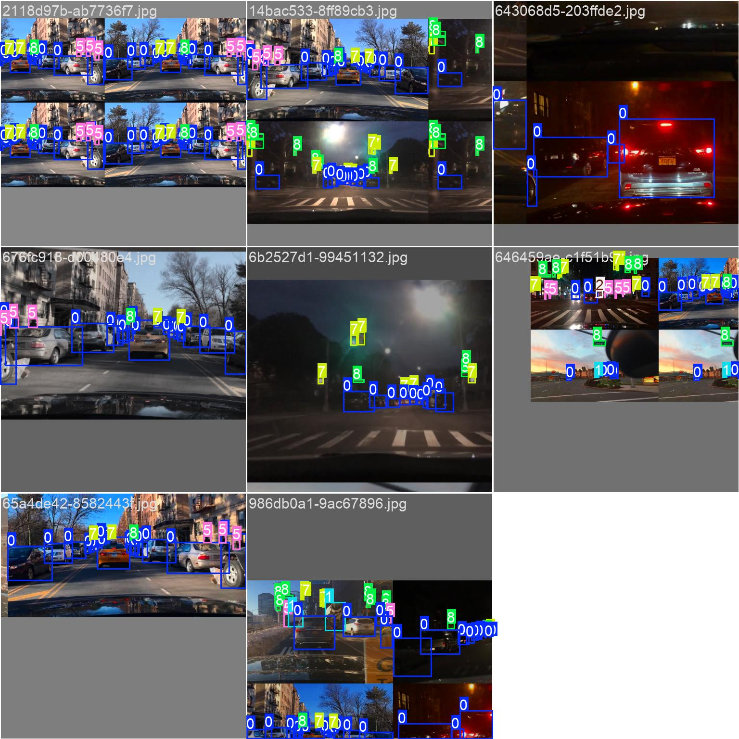
Fig. 1: Training batch sample with bounding box annotations (BDD100K subset)
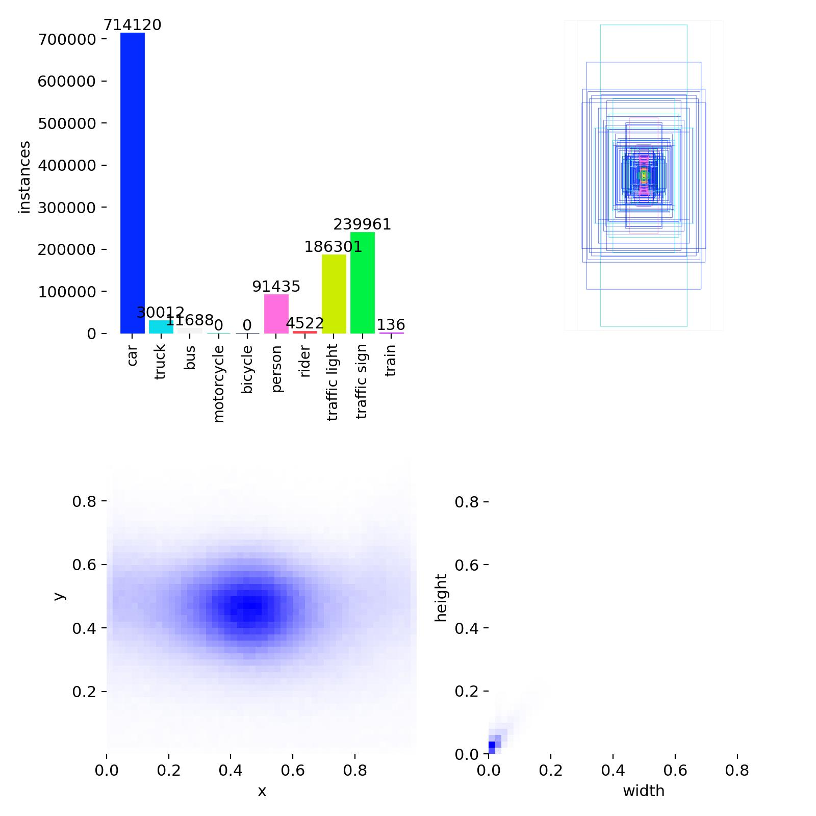
Fig. 2: Dataset label distribution and bounding box statistics (BDD100K subset)
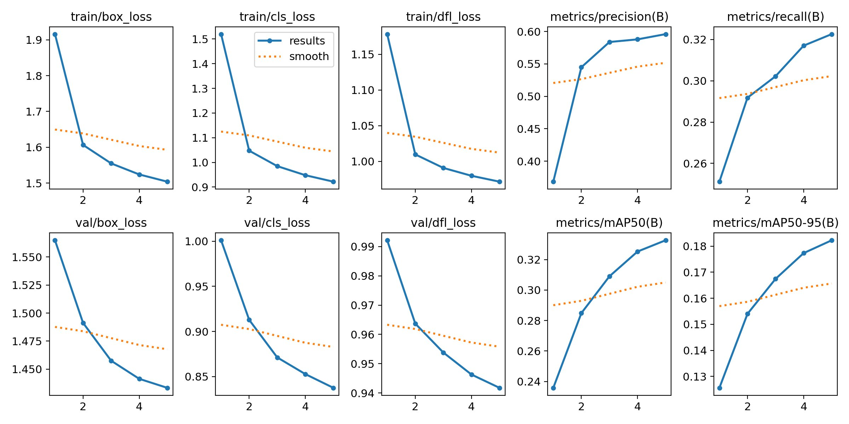
Fig. 3: Training and validation loss curves and performance metrics over epochs
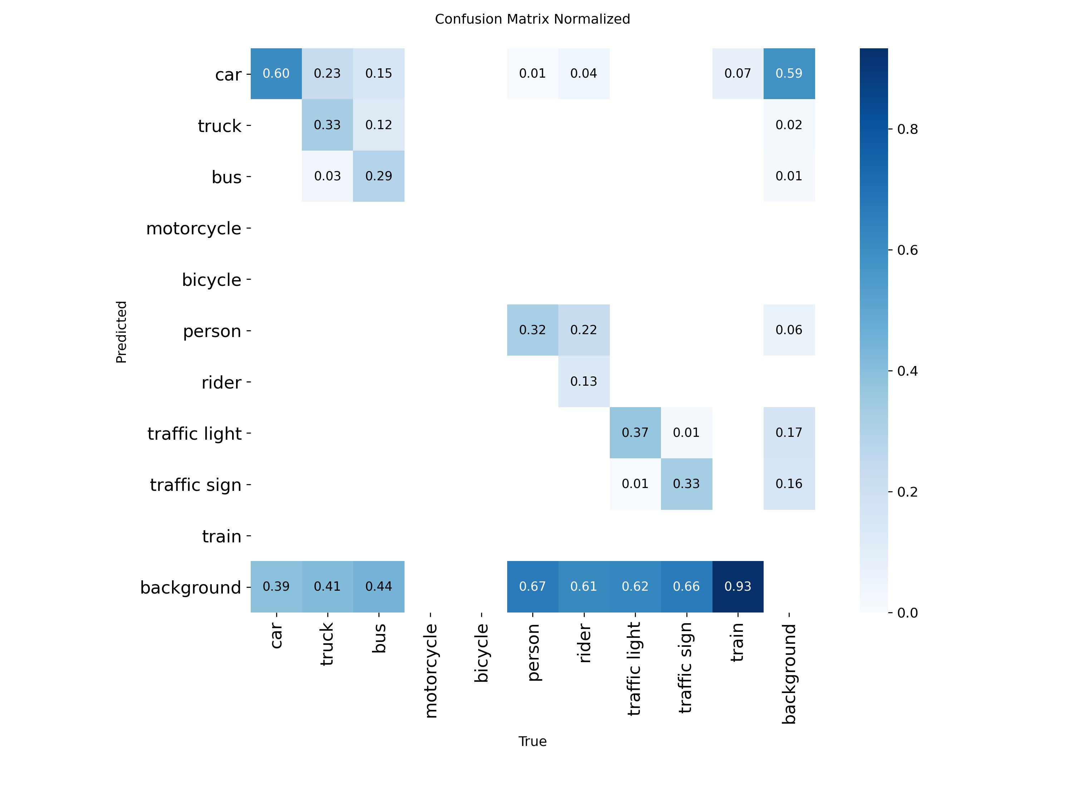
Fig. 4: Normalized confusion matrix showing per-class detection performance
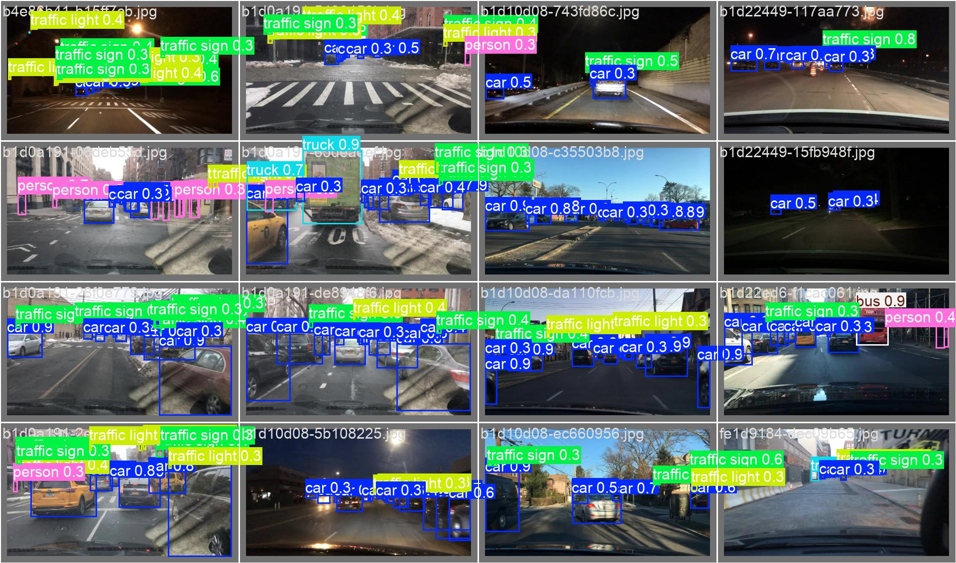
Fig. 5: Validation batch predictions with labelled detections

7. CONCLUSION AND FUTURE SCOPE
The proposed deep learning-based framework presents an effective and scalable solution for autonomous driving in electric vehicles by integrating key components such as object detection, lane detection, and path planning into a unified architecture. The use of YOLOv8 enables accurate and real-time detection of vehicles, pedestrians, and traffic signals, while the lane detection module based on edge detection and polynomial curve fitting ensures reliable identification of road boundaries. The dynamic path planning mechanism further enhances navigation by generating a stable and safe driving trajectory.

The system demonstrates strong performance in terms of real-time processing, achieving approximately 35-55 FPS on GPU-enabled hardware. The application of data augmentation techniques improves model generalization, allowing it to handle variations in lighting, orientation, and scale. Additionally, the integration of explainability techniques such as feature map visualization, saliency maps, and Grad-CAM heatmaps provides deeper insights into the model's internal decision-making process, thereby increasing transparency and trust in the system.

The deployment of the framework using a Flask-based interface enables real-time visualization and interaction with video inputs, making it suitable for testing and demonstration purposes. The modular design of the system ensures flexibility, allowing individual components to be improved or replaced without affecting the overall architecture.

Despite these strengths, the system has certain limitations. The reliance on vision-based inputs makes it sensitive to challenging conditions such as low lighting, weather disturbances, and occlusions. The current implementation does not incorporate multi-sensor data, which is crucial for achieving higher levels of autonomy and reliability. The system also requires further optimization for deployment on resource-constrained embedded devices.

Future work will focus on addressing these limitations by incorporating advanced techniques such as semantic segmentation for more precise scene understanding and sensor fusion using LiDAR, radar, and GPS data to improve robustness. Further enhancements may include integrating reinforcement learning for adaptive decision-making, optimizing the model for edge and embedded systems, and expanding the dataset to include more diverse and region-specific driving conditions. Additionally, improving real-time performance and reducing computational overhead will be key areas of focus to enable large-scale practical deployment.

REFERENCES

[1] J. Redmon, S. Divvala, R. Girshick, and A. Farhadi, "You Only Look Once: Unified, Real-Time Object Detection," Proc. IEEE CVPR, 2016.
[2] A. Bochkovskiy, C. Wang, and H. M. Liao, "YOLOv4: Optimal Speed and Accuracy of Object Detection," arXiv preprint arXiv:2004.10934, 2020.
[3] Ultralytics, "YOLOv8 Documentation," Ultralytics, 2023. [Online]. Available: https://docs.ultralytics.com
[4] F. Yu et al., "BDD100K: A Diverse Driving Dataset for Heterogeneous Multitask Learning," Proc. IEEE CVPR, 2020.
[5] J. Canny, "A Computational Approach to Edge Detection," IEEE TPAMI, vol. 8, no. 6, pp. 679-698, Nov. 1986.
[6] M. Bojarski et al., "End to End Learning for Self-Driving Cars," arXiv preprint arXiv:1604.07316, Apr. 2016.
[7] A. Krizhevsky, I. Sutskever, and G. Hinton, "ImageNet Classification with Deep Convolutional Neural Networks," Advances in Neural Information Processing Systems (NeurIPS), vol. 25, pp. 1097-1105, 2012.
[8] K. Simonyan and A. Zisserman, "Very Deep Convolutional Networks for Large-Scale Image Recognition," Proc. Int. Conf. Learning Representations (ICLR), 2015.
[9] K. He, X. Zhang, S. Ren, and J. Sun, "Deep Residual Learning for Image Recognition," Proc. IEEE CVPR, 2016.
[10] R. Girshick, "Fast R-CNN," Proc. IEEE ICCV, 2015.
[11] S. Ren, K. He, R. Girshick, and J. Sun, "Faster R-CNN," NeurIPS, 2015.
[12] J. Long, E. Shelhamer, and T. Darrell, "Fully Convolutional Networks for Semantic Segmentation," Proc. IEEE CVPR, 2015.
[13] L. Chen et al., "DeepLab: Semantic Image Segmentation with Deep CNNs," IEEE TPAMI, 2018.
[14] D. P. Kingma and J. Ba, "Adam: A Method for Stochastic Optimization," Proc. Int. Conf. Learning Representations (ICLR), 2015.
[15] R. Szeliski, Computer Vision: Algorithms and Applications, New York, NY, USA: Springer, 2010.
[16] P. Viola and M. Jones, "Rapid Object Detection using a Boosted Cascade," Proc. IEEE CVPR, 2001.
[17] G. Bradski, "The OpenCV Library," Dr. Dobb's Journal, vol. 25, no. 11, pp. 120-125, 2000.
[18] A. Geiger, P. Lenz, and R. Urtasun, "Are we ready for Autonomous Driving? The KITTI Vision Benchmark," Proc. IEEE CVPR, 2012.
[19] M. Everingham et al., "The Pascal Visual Object Classes (VOC) Challenge," Int. J. Comput. Vis., vol. 88, no. 2, pp. 303-338, Jun. 2010.
[20] Y. LeCun, Y. Bengio, and G. Hinton, "Deep Learning," Nature, vol. 521, pp. 436-444, 2015.

